Systems in Modern Fighter Aviation
[Type the company name]
[Type the company address]
[Type the phone number]
[Type the fax number]
[Pick the date]
ARUL
[Type the abstract of the document here. The abstract is typically a short summary of the contents of the document. Type the abstract of the document here. The abstract is typically a short summary of the contents of the document.]

Advanced Aeronautics: Aerodynamics, Propulsion, and Integrated Systems in Modern Fighter Aviation
The development of modern fighter aircraft represents the zenith of contemporary engineering, necessitating the harmonious integration of fluid dynamics, thermodynamics, structural mechanics, and advanced computational electronics. These platforms are required to operate across a diverse flight envelope, ranging from low-speed, high-angle-of-attack maneuvers to sustained supersonic cruise. This report provides an exhaustive technical analysis of the fundamental principles governing fighter aviation, exploring the aerodynamic phenomena, propulsive mechanisms, and avionic architectures that define the current generation of tactical aircraft.

Aerodynamic Principles and the Four Forces of Flight
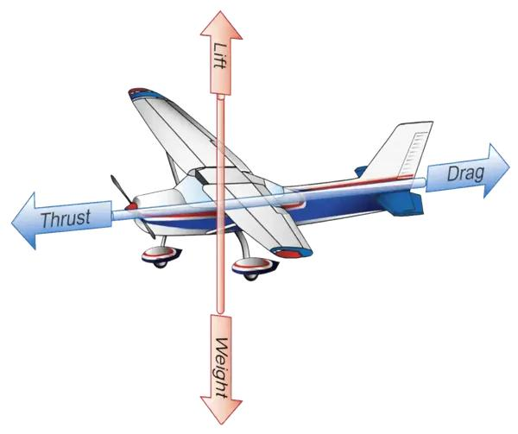
The flight of a fighter jet is a continuous negotiation between four fundamental physical forces: lift, weight, drag, and thrust. The interplay of these vectors determines the aircraft's trajectory, stability, and performance limits. In a state of unaccelerated, level flight, the sum of these forces is zero, establishing a dynamic equilibrium where lift equals weight and thrust equals drag.

1. Lift (Upward Force)

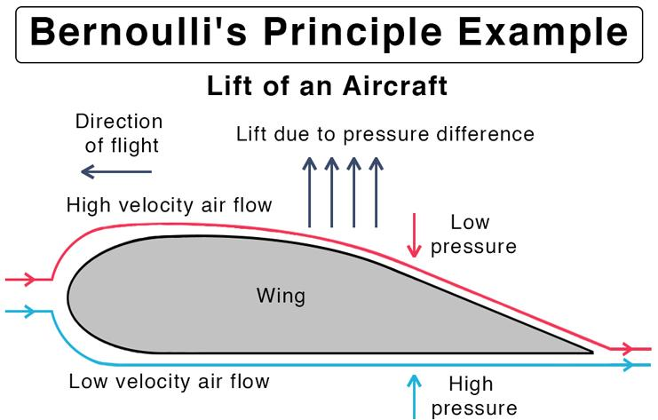
Lift is the force that pushes the airplane upward, opposing gravity.
- Generated by the wings (airfoils)
- Created due to differences in air pressure above and below the wing
- Increases with speed and wing surface area
👉 Without enough lift, the plane cannot take off.

2. Weight (Gravity - Downward Force)
Weight is the force pulling the airplane downward toward Earth.
- Caused by gravity
- Depends on aircraft mass (fuel, passengers, cargo)
👉 Lift must balance weight for steady flight.

3. Drag (Backward Force)
Drag is the force that opposes motion, acting backward.
- Caused by air resistance
- Increases with speed and surface roughness
👉 Engineers design aircraft to reduce drag as much as possible.
4.Thrust (Forward Force)
Thrust moves the airplane forward.
- Produced by engines (jet engines or propellers)
- Helps the aircraft gain speed for lift
👉 Without thrust, the plane cannot move forward or climb.

The Dynamics of Weight and Center of Gravity
Weight is the force exerted by gravity on the total mass of the aircraft, encompassing the airframe, engines, avionics, pilot, payload, and fuel. For a fighter jet, weight is a highly dynamic variable. A significant portion of a fighter's takeoff mass is fuel, which is consumed at varying rates depending on the mission profile—extremely high during afterburner-assisted combat and lower during high-altitude cruise.
This gravitational force acts through a single theoretical point known as the center of gravity (CG). The position of the CG is critical for flight stability; in flight, the aircraft rotates around this point. As fuel is depleted or weapons are released, the CG shifts. Modern flight control systems (FCS) must continuously monitor and compensate for these shifts to maintain the desired attitude. If the CG moves beyond established forward or aft limits, the aircraft may become longitudinally unstable or resistant to pitch commands.

Lift Generation and Circulation Theory
Lift is the aerodynamic force generated by the motion of the aircraft through the air, acting perpendicular to the flight path. While the entire airframe contributes to lift, the wings and high-lift devices are the primary generators. The mechanism of lift is traditionally explained through a combination of Bernoulli’s Principle and Newton’s Third Law. Bernoulli’s Principle relates the velocity of the airflow to its static pressure, suggesting that the curved upper surface of a wing (the camber) forces air to travel faster, creating a low-pressure region that "pulls" the wing upward. Simultaneously, Newton’s Third Law dictates that as the wing deflects air downward, an equal and opposite reaction force is exerted upward on the wing.
The mathematical representation of lift is expressed through the lift equation:
L=21​ρv2SCL​
In this expression, L is lift, ρ is the air density, v is the velocity of the aircraft, S is the wing surface area, and CL​ is the lift coefficient. For fighter jets, the lift coefficient is highly dependent on the angle of attack (AoA), which is the angle between the wing's chord line and the oncoming airflow.

Drag Mechanisms and Wave Resistance
Drag is the resistance force that opposes the motion of the aircraft through the atmosphere. It is composed of several distinct types:
- Skin Friction Drag: Caused by the "stickiness" or viscosity of the air as it passes over the aircraft's surface.
- Form Drag: Arises from the physical shape and size of the aircraft, which creates a pressure differential between the front and rear.
- Induced Drag: An unavoidable byproduct of lift generation, caused by the formation of wingtip vortices that tilt the lift vector backward.
- Wave Drag: Predominant in transonic and supersonic regimes, where the formation of shock waves creates a massive increase in resistance.
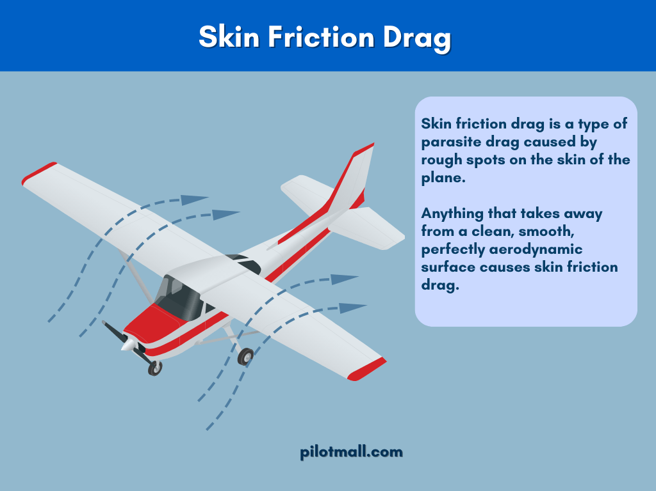
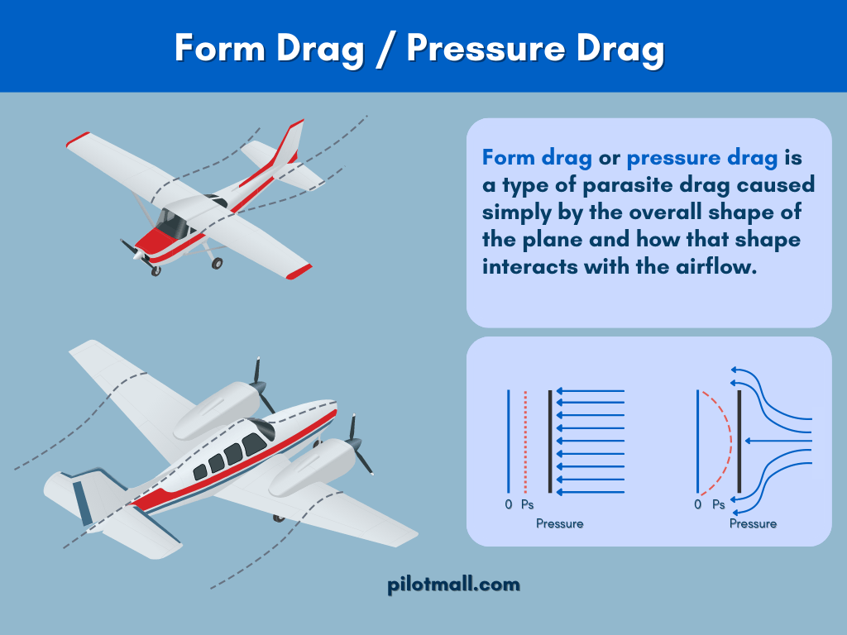

Thrust is the forward-acting force produced by the propulsion system to overcome drag and accelerate the aircraft. Fighter jets utilize gas turbine engines to accelerate a mass of air backward, producing a forward reaction force. The magnitude of thrust depends on the mass flow rate of the air and the velocity change imparted by the engine.
Force | Primary Vector Direction | Dependence Factors
Lift | Perpendicular to flight path | Velocity, Air Density, Wing Area, CL​
Weight | Toward the center of the Earth | Mass (Fuel, Payload, Airframe)
Thrust | Along the flight path (Forward) | Fuel Flow, Air Intake, Nozzle Exit Velocity
Drag | Along the flight path (Backward) | Airframe Shape, Speed, Air Viscosity
Axes of Motion and Aerodynamic Control Surfaces
To navigate and maneuver in three-dimensional space, a fighter jet must be capable of rotating about three mutually perpendicular axes. These rotations are achieved through the manipulation of control surfaces that alter the local aerodynamic forces.

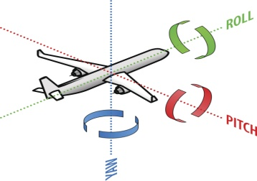
The Three Principal Axes
- The Longitudinal Axis (Roll): Extending from the nose to the tail, rotation about this axis is called roll. It is primarily controlled by the ailerons located on the trailing edges of the wings. By moving in opposite directions, ailerons increase lift on one wing while decreasing it on the other, causing the aircraft to tilt.
- The Lateral Axis (Pitch): Running from wingtip to wingtip, rotation about this axis is called pitch. This dictates the up-or-down movement of the nose and is controlled by the elevators, typically part of the horizontal stabilizer. Raising the elevators creates a downward force on the tail, pivoting the nose upward.
- The Vertical Axis (Yaw): Passing from the top to the bottom of the aircraft, rotation about this axis is called yaw. This side-to-side motion is managed by the rudder, located on the vertical stabilizer.

Secondary and Advanced Control Surfaces
Modern fighter designs often incorporate additional surfaces to enhance maneuverability and stability.
- Canards: Small forewings located ahead of the main wing. Canards can be used to control pitch, improve lift at high angles of attack, and delay stall by energizing the airflow over the main wing.
- Leading Edge Root Extensions (LERX): These are forward extensions of the wing root that generate powerful vortices. These vortices remain attached to the upper surface of the wing at high AoA, providing additional "vortex lift" and preventing flow separation.
- Flaps and Slats: Located on the trailing and leading edges respectively, these surfaces increase the wing's camber and surface area to provide higher lift at low speeds, such as during takeoff and landing.

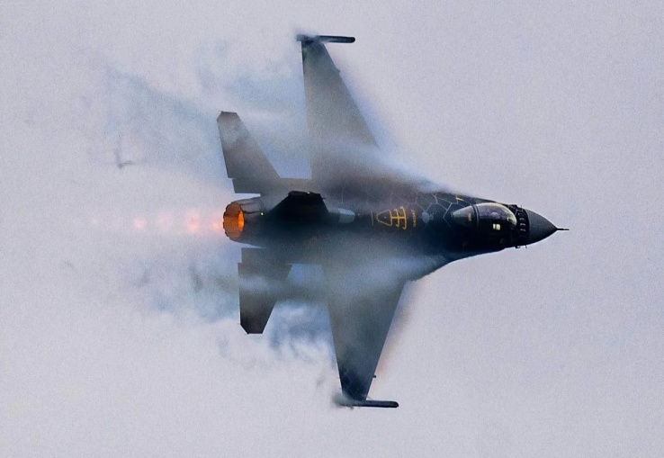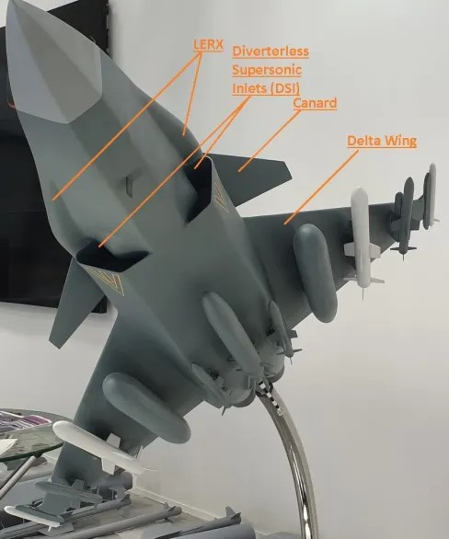
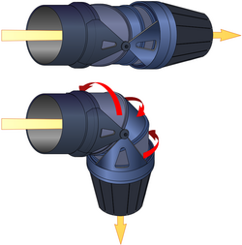

Thrust Vectoring Control (TVC): While not a traditional aerodynamic surface, TVC works in tandem with them. By redirecting the engine's exhaust via movable vanes or pivoting engine nozzles, TVC provides direct turning force, allowing the jet to maneuver even at speeds too low for standard aerodynamic surfaces to function.

Vortex Dynamics and Supermaneuverability
One of the defining characteristics of modern fighter aerodynamics is the utilization of vortex flow. Unlike commercial aircraft, which rely almost exclusively on attached potential flow, fighter jets exploit separated flow to maintain control at extreme angles of attack.

The Role of Vortex Lift
In delta-wing configurations or aircraft with LERX, as the angle of attack increases, the air flowing over the sharp leading edges separates and rolls up into a stable, high-energy vortex core. This vortex creates a region of very low pressure on the upper surface of the wing, which generates a significant amount of lift—often referred to as vortex lift. This phenomenon allows fighters to maintain lift at AoA that would cause a traditional wing to stall.
However, this vortex system is subject to "vortex breakdown" or "bursting." This occurs when the pressure along the vortex core increases to the point where the organized rotation collapses into a turbulent, stagnant wake. The GAMA water tunnel is a primary research tool used to visualize these dynamics, allowing engineers to identify the exact location of breakdown using fluorescent dye and laser-induced fluorescence.
Vortex Breakdown Type | Characteristics | Impact on Maneuverability
Bubble Type | Stagnation point followed by a recirculating bubble | Causes abrupt loss of lift and pitch-up
Spiral Type | Rapid deceleration and helical twisting of the core | Leads to asymmetric forces and wing rock
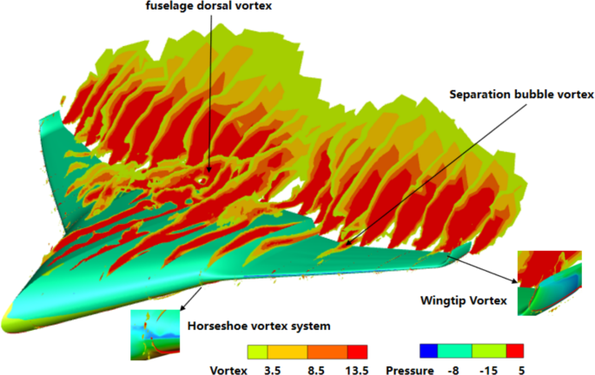
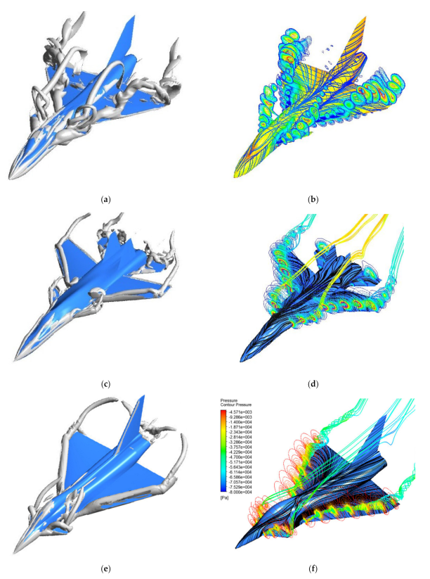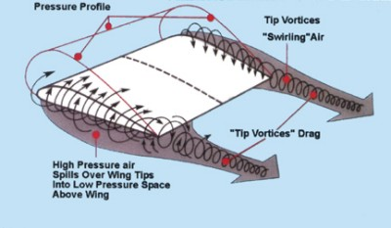

Post-Stall Maneuvers: The Pugachev Cobra
Supermaneuverability refers to the ability of an aircraft to perform controlled maneuvers at angles of attack far beyond the normal stall limit. The Pugachev Cobra is a quintessential example of this capability. During this maneuver, the aircraft abruptly raises its nose to a vertical or even slightly past-vertical attitude (up to 110-120 degrees AoA) while maintaining its original horizontal flight path.

The physics of the Cobra rely on "aerodynamic instability" and the ability to rapidly change AoA without airframe failure. For a brief moment, the aircraft acts as a massive aerodynamic brake, bleeding kinetic energy and dropping its airspeed nearly to zero. Recovery is achieved by pushing the nose forward and using high-thrust engines to restore normal airflow over the surfaces. This maneuver can be used defensively to force a pursuing aircraft to overshoot or to momentarily point the nose at a target for a missile lock.

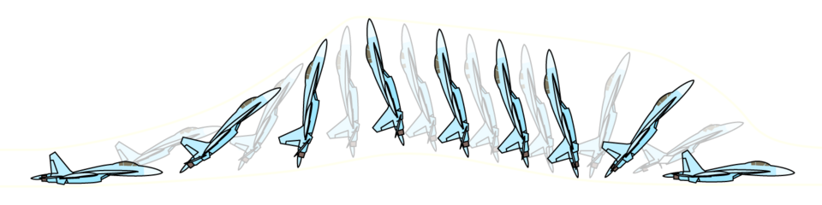

Computational Fluid Dynamics (CFD) in Maneuverability Analysis
Modern aerodynamic research relies heavily on CFD to model these complex, nonlinear regimes. Traditional empirical codes like DATCOM are often insufficient for modeling three-surface configurations (canard, wing, tail) or the transonic regime. Engineers now utilize Reynolds-Averaged Navier-Stokes (RANS) simulations, specifically the SST k-ω turbulence model, to predict vortex breakdown locations and calculate aerodynamic forces at high AoA.

Propulsion Systems and Thermodynamic Cycles
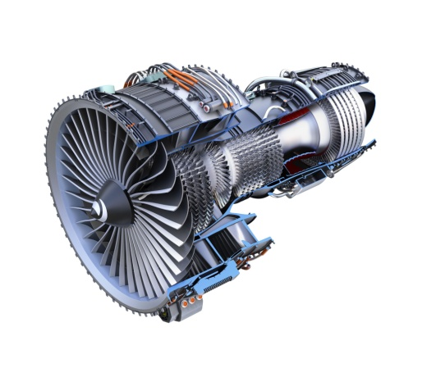
The propulsion system of a modern fighter is typically a low-bypass turbofan engine, which offers a balance between high-speed performance and fuel efficiency. These engines operate on the Brayton Thermodynamic Cycle, a series of processes involving compression, combustion, and expansion.

The Brayton Cycle in Gas Turbine Engines
The thermodynamics of a jet engine can be analyzed through a series of "stations" representing different stages of the flow.
- Station 0 to 2 (Intake/Inlet): Air is brought into the engine. In supersonic flight, the inlet is designed to slow the air to subsonic speeds before it reaches the compressor, converting kinetic energy into a pressure rise.
- Station 2 to 3 (Compression): The compressor does work on the gas, increasing its pressure and temperature isentropically (in an ideal state). A typical engine might take in 1.2 tons of air per second.
- Station 3 to 4 (Combustion/Burner): Fuel is combined with the air and ignited at constant pressure. This dramatically increases the temperature of the gas.
- Station 4 to 5 (Turbine): The hot exhaust gases expand through the turbine, which extracts energy to drive the compressor and other accessories.
- Station 5 to 8 (Nozzle): The nozzle accelerates the flow back to free-stream pressure, generating thrust.
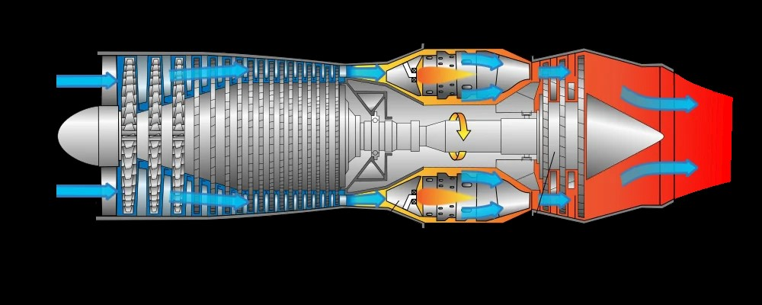
The net thrust (F) produced by the engine is given by the general thrust equation:
F=m˙Ve​−m˙0​V0​+(pe​−p0​)Ae​
For most jet engines, the pressure-area term (pe​−p0​)Ae​ is zero as the nozzle expands the flow to ambient pressure.

Thrust Augmentation: The Afterburner
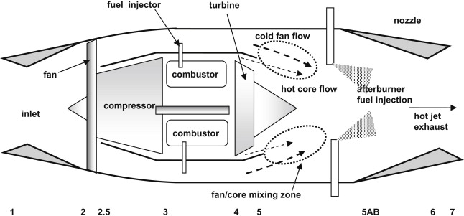
One of the most effective methods for thrust augmentation in fighter jets is the afterburner. This system involves injecting and burning fuel in a special combustor located after the gas turbine but before the exhaust nozzle. Because the core engine operates at high air-to-fuel ratios, the exhaust gas contains sufficient oxygen to support further combustion. This process significantly increases the temperature and volume of the exhaust, leading to much higher exit velocities and, consequently, more thrust.
The control of an afterburner is a complex task. Mathematical models are used to manage the fuel flow rate (Qi​) and injection pressure based on the engine speed (n) and the flight regime (inlet total pressure p1∗​).
The linearized motion equation for an afterburner fuel pump actuator can be represented as: ms​dt2d2Δy​+ξdtdΔy​+kea​Δy=SA​ΔpA​−SB​ΔpB​
Where ms​ is the mass of the actuator rod, y is the displacement, and p represents the pressures acting on the piston.
Component | Function | Material Requirement
Compressor | Squeezes air to high pressure | Titanium or Nickel alloys
Combustion Chamber | Mixes fuel/air and ignites | High-temperature ceramics/superalloys
Turbine | Extracts energy to turn compressor | Single-crystal superalloys (to prevent creep)
Nozzle | Accelerates exhaust to create thrust | Heat-resistant alloys with RAM coatings
Fuel Systems and Fluid Management
The fuel system of a fighter jet must reliably supply fuel to the engine and afterburner under all flight conditions, including high-G maneuvers and extreme altitudes.

System Architecture and Components
The airframe fuel system begins with storage tanks and ends at the engine's fuel metering device. Modern fighters utilize a variety of pumps and valves to manage flow:
- Booster Pumps: Located within the tanks, these pumps keep the fuel lines pressurized to reduce vapor formation (vapor lock) during rapid climbs.
- Center Tank Override Pumps: These have higher output pressure than wing tank pumps, ensuring that fuel in the center tank is consumed first to maintain the aircraft's center of gravity.
- Scavenge Pumps: Automatically transfer any remaining fuel from the center tank to the main tanks as the levels drop.
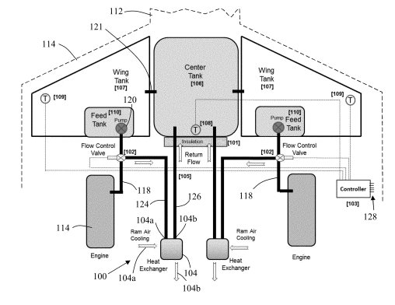
- Crossfeed Valves: Allow any tank to supply either engine, which is vital for balancing the fuel load or in the event of a pump failure.

Diagram: Fuel Flow Path
- Tank Storage: Fuel is kept in wing and fuselage tanks.
- Booster Pump: Pressurizes fuel into the main lines.
- Fuel Control Unit (FCU/FADEC): Meters the precise amount of fuel needed based on throttle position and sensor data.
- Fuel Manifold: Distributes metered fuel to the individual discharge nozzles in the burner or afterburner.

Avionics and Sensor Fusion
Avionics are the electronic systems used for navigation, communication, and mission management. In the current generation of fighters, the shift has been from federated systems to highly integrated architectures characterized by sensor fusion.

AESA Radar: The Primary Sensor
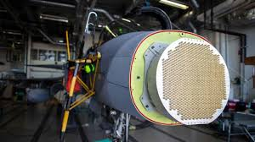
The Active Electronically Scanned Array (AESA) radar represents the current state-of-the-art in detection technology. Unlike older passive radars with mechanically moving dishes, an AESA radar uses thousands of tiny transmit/receive (T/R) modules that work like pixels. These modules can be steered electronically in microseconds, allowing the radar to track multiple targets while simultaneously performing ground mapping and electronic warfare tasks. The AN/APG-81 radar used in the F-35 is a primary example, offering long-range active and passive modes.

Multi-Sensor Fusion and Situational Awareness
Sensor fusion is the automated process of analyzing data from multiple sources—radar, electro-optical systems, and electronic warfare suites—to provide a single, intuitive picture to the pilot.
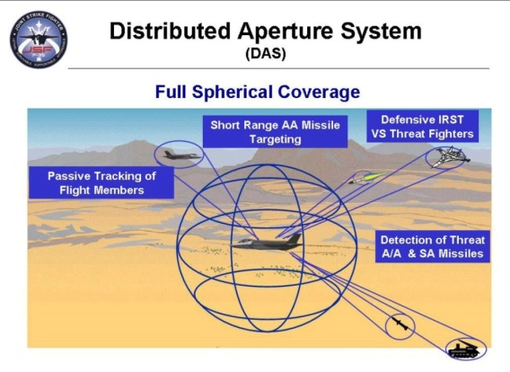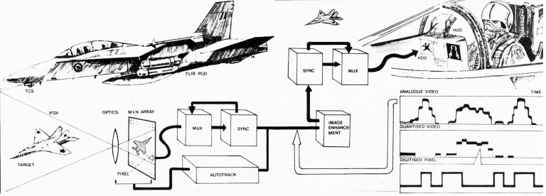
- Electro-Optical Targeting System (EOTS): Integrated into the fuselage to reduce radar cross-section (RCS). It provides long-range detection and precision targeting against ground and air targets.
- Distributed Aperture System (DAS): Consists of six infrared cameras mounted around the aircraft, providing 360-degree situational awareness. The images are projected directly onto the pilot’s helmet visor, effectively allowing the pilot to "see through" the airframe.
- Helmet-Mounted Display (HMD): Replaces the traditional Head-Up Display (HUD) by projecting flight data and target symbology directly onto the pilot's line of sight.

Data Bus Standards: MIL-STD-1553 and 1760
The backbone of the avionic system is the data bus, which enables communication between the various computers and sensors.
- MIL-STD-1553: A serial data bus that uses time-division multiplexing and a command/response protocol. It features dual redundancy and is built to withstand extreme mechanical stress and electromagnetic interference. It typically operates at a 1 Mbps data rate.
- MIL-STD-1760: An extension of the 1553 standard designed specifically for weapon integration. It provides both high-speed data and electrical power (28 VDC and 115/200 VAC) through a standardized connector, enabling "plug-and-play" capability for smart bombs and missiles.
Feature | MIL-STD-1553 | MIL-STD-1760
Primary Use | General Avionics/Control | Weapon System Integration
Data Rate | 1 Mbps | High-speed (multi-protocol support)
Power Delivery | Data only (separate power lines) | Combined Data and Power
Redundancy | Dual-redundant bus | Inherits 1553 redundancy

Structures, Materials, and Stealth Technology
The structural design of a fighter jet must balance the requirements for high-G strength, thermal resistance, and low radar observability.

Structural Materials: Titanium and Carbon Fiber
Modern fighters make extensive use of composite materials and high-strength alloys.
- Carbon Fiber Reinforced Polymers (CFRP): Used for up to 50% of the airframe weight in platforms like the B-2. CFRP is stronger than steel and lighter than aluminum, providing an excellent strength-to-weight ratio and inherent radar absorption properties.
- Titanium: Strategically used in high-stress areas like the main wing spars and the engine compartment where thermal resistance is paramount.
- Honeycomb Structures: Multi-layer sandwich structures with metal-coated dielectric fibers are used to provide broadband electromagnetic absorption while maintaining structural integrity for large wing surfaces.

Radar Cross-Section (RCS) Reduction and Stealth
Radar Cross Section (RCS) is the measure of how detectable an object is to a radar system. Stealth technology, or Low Observability (LO), aims to reduce the distance at which an aircraft can be detected by radar. This is achieved through two primary methods: shaping and material selection.

Geometric Shaping Principles
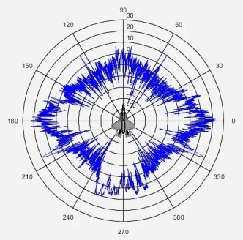
- Planform Alignment: Aligning the edges of wings, stabilizers, and intakes to a few specific angles. This ensures that radar energy is reflected in very narrow directions, leaving the aircraft "invisible" from most other angles.
- Serrated Edges: Used on landing gear doors and access panels to break up the radar return and disperse it away from the transmitter.
- Canted Vertical Tails: Tilted away from the vertical to avoid the strong specular return that a 90-degree corner reflector (between the tail and wing) would produce.
- Serpentine Ducts: Using "S-shaped" air intakes to hide the highly reflective engine fan blades from frontal radar waves.

Radar Absorbing Materials (RAM)
RAM coatings are used to convert electromagnetic energy into heat. Carbon-based materials, including carbon black, carbon nanotubes, and graphene, are preferred for their lightweight nature and excellent dielectric properties. These materials can be tuned to absorb specific frequency bands, from the L-band (long-range search) to the high-resolution Ku-band.
Radar Band |  | Frequency Range (GHz) | Typical Use Case
 | L Band | 1.0 – 2.0 | Long-range air traffic control/search
 | S Band | 2.0 – 4.0 | Weather and long-range tracking
 | C Band | 4.0 – 8.0 | Weapon location and tracking
 | X Band | 8.0 – 12.5 | Missile guidance and airborne intercept
 | Ku Band | 12.5 – 18.0 | High-resolution mapping

Maneuverability and High-Alpha Performance
The combat effectiveness of a fighter jet is often measured by its energy management—the ability to conserve kinetic and potential energy during maneuvers. This is governed by John Boyd’s Energy-Maneuverability theory, which redefined air combat by focusing on the aircraft's ability to change its energy state faster than the opponent.
A key factor in modern maneuverability is the thrust-to-weight ratio. If an aircraft's thrust exceeds its weight (ratio > 1), it can accelerate while in a vertical climb. Furthermore, "relaxed static stability" (RSS) is often employed, where the aircraft is designed to be inherently unstable. This instability allows for much faster pitch rates and turns, but requires a computer-controlled Fly-By-Wire (FBW) system to keep the aircraft controllable for the pilot.

Synthesis and Conclusion
The engineering of a modern fighter jet is an exercise in managing extreme physical and electronic constraints. The aerodynamic design must facilitate both supersonic efficiency and high-alpha maneuverability, often through the clever use of vortex lift and canard-wing interactions. The propulsion system must be integrated into this aerodynamic frame while providing massive thrust via the Brayton cycle and afterburning reheat.
Simultaneously, the airframe must be a digital node within a larger network. Avionics suites powered by AESA radars and multi-sensor fusion algorithms process vast amounts of data, delivering actionable situational awareness to the pilot via helmet-centric interfaces. These complex systems are interconnected by robust data buses like the MIL-STD-1553 and 1760 standards.
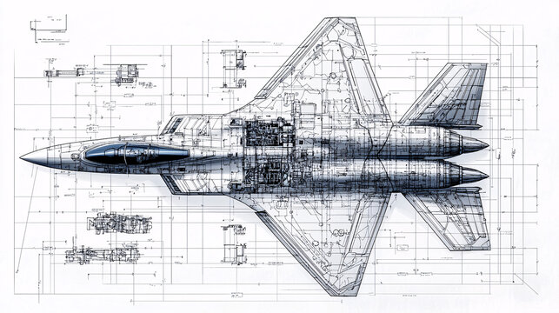
Finally, the survivability of the platform is ensured through the application of stealth principles—a synergy of geometric shaping and advanced carbon-based radar-absorbing materials. As the field progresses toward sixth-generation designs, the trends indicate an even greater reliance on artificial intelligence for sensor fusion and the potential for adaptive cycle engines that can optimize performance across subsonic and supersonic regimes. The fighter jet remains one of the most sophisticated expressions of human technological achievement, a machine that pushes the boundaries of physics and material science to achieve dominion over the skies.
____________________________

